25Q4 Sprint Item 19937 Helpdesk-dev

Introduction:

The purpose of this penetration testing document is to assess the security posture of the application by identifying vulnerabilities, misconfigurations, and potential attack vectors that could be exploited by malicious actors. Penetration testing is a proactive measure designed to uncover weaknesses before they can be leveraged in real-world scenarios.
This assessment was specifically carried out to evaluate the changes introduced during the recent sprint meet. By focusing on newly implemented features, modifications, and updates, the testing ensures that security risks are identified early in the development cycle and addressed before deployment.
The objectives of this assessment are to:
- Detect security flaws that may compromise confidentiality, integrity, or availability of data
- Validate that the changes made during the sprint meet do not introduce new vulnerabilities
- Provide actionable insights to strengthen the application’s resilience against cyberattacks
- Support compliance and risk management by aligning with industry best practices and regulatory requirements
By simulating adversarial techniques in a controlled environment, this document highlights areas requiring remediation and offers recommendations to mitigate risks. The ultimate goal is to safeguard sensitive information, maintain trust with stakeholders, and ensure the application operates securely in production environments.

Table of Contents
Introduction: 2
25Q4 Sprint Item 19937 Helpdesk-dev 4

25Q4 Sprint Item 19937 Helpdesk-dev
Application Under Test:
The application under test is the Helpdesk-dev.zalaris.com.
Changes Introduced in Sprint:
During the recent sprint, Pagination was added for easy navigation and UI changes were made to add card for the Tiles available.
Current Testing Scope:
The current testing scope includes the following
- Boundary Testing
- Authorization and Access Control testing
- Business Logic testing
- Injection Test
- Error Handling and Stack Traces
- Rate Limiting
- Caching and Sensitive Data Exposure
- Response Consistency and Data Integrity

Boundary Testing
Test how the application behaves when currentPage is altered intentionally.
Objective:
Check for unhandled exceptions, backend errors, pagination logic flaws, or unintended record disclosure.
Capture the request when navigation the page using pagination
Parameter current-page is found in the request
Refer screenshot attached for supporting evidence
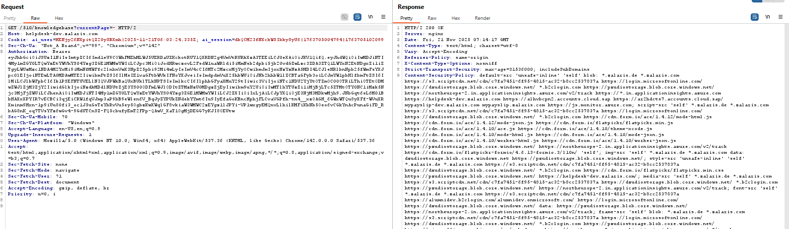
Payloads tested in BurpSuite’s repeater and their result is given below
Payload | Result
currentPage=0 [zero value] | No Issue Found
currentPage=* [Regex Pattern] | No Issue Found
currentPage=-1 [Normal Value] | No Issuse Found
currentPage=999999999999 [Value exceeding expected input] | No Issue Found
currentPage=abc [String Value] | No Iuuse Found
currentPage=!@#$%^&* [Special Character] | No Iuuse Found
currentPage=1.5 [Float type] | No Iuuse Found
Null, empty and missing values
currentPage= [Null value] | No Iuuse Found
currentPage [No value] | No Iuuse Found
Extreme Values
currentPage=0x999999 [Hex value] | No Iuuse Found
currentPage=999e9 [Scientific Notation] | No Iuuse Found
Floating Point and Decimal variant
currentPage=1.5 [comma varient] | No Iuuse Found
currentPage=.5 | No Iuuse Found
White Spacing and Encoding variations
currentPage= 1 | No Iuuse Found
currentPage=%201 (space encoded) | No Iuuse Found
currentPage=%00 (null byte) | No Iuuse Found
currentPage=%2e%2e (encoded dots) | No Iuuse Found
Special Characters and Fuzz Strings
currentPage=’ | 400 Bad Request
currentPage=” | No Issue Found
currentPage=(){}[] | No Issue Found
currentPage=<> | No Issue Found
currentPage=../../ | No Issue Found
currentPage=%% | No Issue Found
Injection Oriented Inputs SQL Like Patterns
currentPage=1 OR 1=1 | No Issue Found
currentPage=1'-- | No Issue Found
currentPage=' OR 'a'='a | No Issue Found
XSS like Patterns
currentPage=<script>alert(1)</script> | No Issue Found
currentPage="><img src=x onerror=alert(1)> | No Issue Found
Path / template Injection Patterns
currentPage={{7*7}} | No Issue Found
currentPage=${7*7} | No Issue Found
Type Confusion and Structure Manipulation
currentPage[]=1 | No Issue Found
currentPage[page]=1 | No Issue Found
currentPage={"page":1} | No Issue Found
currentPage=true | No Issue Found
currentPage=null | No Issue Found
currentPage=[1] | No Issue Found
Unicode and Internationalization cases
currentPage=١ (Arabic Numeral) | No Issue Found
currentPage=一 (Chinese Numeral) | 400 Bad Request
currentPage= １２３ | 400 Bad Request
currentPage=１.５ | 400 Bad Request
Observer behavior : for the payloads ‘, 一 (Chinese Numeral), １２３,１.５ the server returns 400 Bad Request
Test result using the same payload in the GUI is given below
Payload | Result
currentPage=0 [zero value] | Re-directed to page 1 no error thrown
currentPage=* [Regex Pattern] | Re-directed to page 1 no error thrown
currentPage=-1 [Normal Value] | Re-directed to page 1 no error thrown
currentPage=999999999999 [Value exceeding expected input] | The following error is received 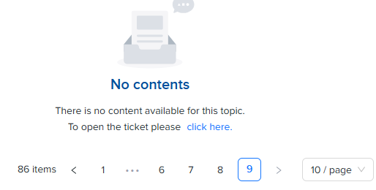
currentPage=abc [String Value] | Re-directed to page 1 no error thrown
currentPage=!@#$%^&* [Special Character] | Re-directed to page 1 no error thrown
currentPage=1.5 [Float type] | Different page is given rather than redirection to Page 1 sc attached below 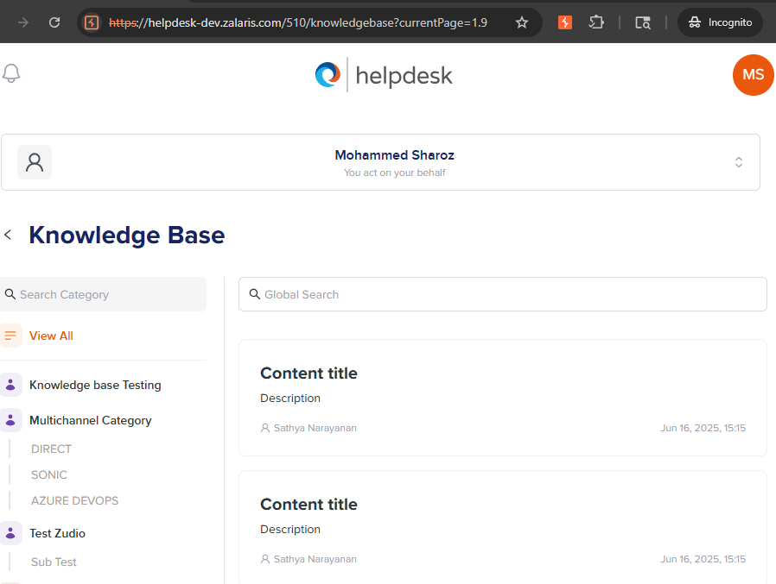
Null, empty and missing values
currentPage= [Null value] | Re-directed to page 1 no error thrown
currentPage [No value] | Re-directed to page 1 no error thrown
Extreme Values
currentPage=0x999999 [Hex value] | Received the following Error 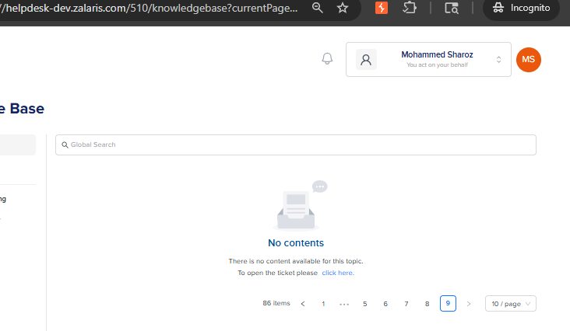
currentPage=999e9 [Scientific Notation]
Floating Point and Decimal variant
currentPage=1,5 [comma varient] | Re-directed to page 1 no error thrown
currentPage=.5 | Page one shown but without any content sc attached below  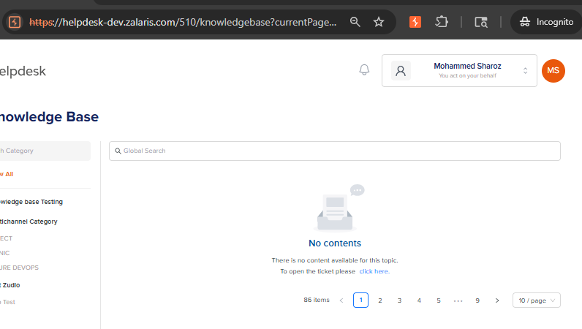
White Spacing and Encoding variations
currentPage= 1 | Re-directed to page 1 no error thrown
currentPage=%201 (space encoded) | Re-directed to page 1 no error thrown
currentPage=%00 (null byte) | Re-directed to page 1 no error thrown
currentPage=%2e%2e (encoded dots) | Re-directed to page 1 no error thrown
Special Characters and Fuzz Strings
currentPage=’ | Re-directed to page 1 no error thrown
currentPage=” | Re-directed to page 1 no error thrown
currentPage=(){}[] | Re-directed to page 1 no error thrown
currentPage=<> | Re-directed to page 1 no error thrown
currentPage=../../ | Re-directed to page 1 no error thrown
currentPage=%% | Re-directed to page 1 no error thrown
Injection Oriented Inputs SQL Like Patterns
currentPage=1 OR 1=1 | Re-directed to page 1 no error thrown
currentPage=1'-- | Re-directed to page 1 no error thrown
currentPage=' OR 'a'='a | Re-directed to page 1 no error thrown
XSS like Patterns
currentPage=<script>alert(1)</script> | Re-directed to page 1 no error thrown
currentPage="><img src=x onerror=alert(1)> | Re-directed to page 1 no error thrown
Path / template Injection Patterns
currentPage={{7*7}} | Re-directed to page 1 no error thrown
currentPage=${7*7} | Re-directed to page 1 no error thrown
Type Confusion and Structure Manipulation
currentPage[]=1 | Re-directed to page 1 no error thrown
currentPage[page]=1 | Re-directed to page 1 no error thrown
currentPage={"page":1} | Re-directed to page 1 no error thrown
currentPage=true | Re-directed to page 1 no error thrown
currentPage=null | Re-directed to page 1 no error thrown
currentPage=[1] | Re-directed to page 1 no error thrown
Unicode and Internationalization cases
currentPage=١ (Arabic Numeral) | Re-directed to page 1 no error thrown
currentPage=一 (Chinese Numeral) | Re-directed to page 1 no error thrown
currentPage= １２３ | Re-directed to page 1 no error thrown
currentPage=１.５ | Re-directed to page 1 no error thrown
Excessive value, float value, hex value and scientific notation value were parsed by the application and application deviates from the normal response in GUI
This has to be further tested for escalation of impact
Authorization and Access Control Testing
If different pages reveal different sets of data:
Try requesting pages that should not belong to the authenticated user.
Ensure that changing currentPage does not allow access to data from other users, roles, or tenants.
Objective: Identify IDOR-style issues and broken access control.

Check whether there is any user specific or role-specific , tenant-specific
What are the type of data returned by each page ?
Business Logic Testing
Injection Test

Error Handling and Stack Traces

Rate Limiting

Caching and Sensitive Data Exposure

Response Consistency and Data Integrity

WORKLOG

When | What | Who | Recommended Action
21 November 2025 | Helpdesk-dev Sprint Item 19937 manual test | Mohammed Sharoz | Test in Progress parameter currentPage accepts floating point integer

